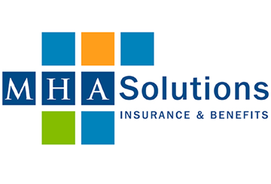

**Let’s Work Together to Address Employee Mental Health**

We want to help you support your employees’ mental health. Reviewing your plan designs and benefits offerings is the first step. Contact us at MHA Solutions to discuss your current offerings and to learn more about the mental health resources that you can provide to your employees.